Case study – The Titanic disaster CMIBOD021T – G. Costantini

**Important notes**:

* You can work in groups of *two* students, but the final report is *individual*. The R *code* and the *plots/visualization* can be the same, but the *comments/explanations/answers* must be different from each other.
* After the delivery, the teacher has the possibility to ask you to explain (in person) what you wrote in this report, to check the autenticity of the contents.
* Fill this document with your answers (code, outputs, explanations, etc…) and upload it on N@tschool *before* the deadline: midnight of Sunday 08 November 2015 (end of week 9).

Student name: Jeroen van der Steen

Student number: 0867254

School/Opleiding: Hogeschool Rotterdam, Media Technologie

1. [*Week 1; Chapters 1,2 Dalgaard*] Download the dataset “train.csv” from the Kaggle website (<https://www.kaggle.com/c/titanic-gettingStarted/data>) or from N@tschool. Read from the website the columns description. Import the dataset into R and examine its contents.

VARIABLE DESCRIPTIONS:

survival Survival

(0 = No; 1 = Yes)

pclass Passenger Class

(1 = 1st; 2 = 2nd; 3 = 3rd)

name Name

sex Sex

age Age

sibsp Number of Siblings/Spouses Aboard

parch Number of Parents/Children Aboard

ticket Ticket Number

fare Passenger Fare

cabin Cabin

embarked Port of Embarkation

(C = Cherbourg; Q = Queenstown; S = Southampton)

SPECIAL NOTES:

Pclass is a proxy for socio-economic status (SES)

1st ~ Upper; 2nd ~ Middle; 3rd ~ Lower

Age is in Years; Fractional if Age less than One (1)

If the Age is Estimated, it is in the form xx.5

With respect to the family relation variables (i.e. sibsp and parch)

some relations were ignored. The following are the definitions used

for sibsp and parch.

Sibling: Brother, Sister, Stepbrother, or Stepsister of Passenger Aboard Titanic

Spouse: Husband or Wife of Passenger Aboard Titanic (Mistresses and Fiances Ignored)

Parent: Mother or Father of Passenger Aboard Titanic

Child: Son, Daughter, Stepson, or Stepdaughter of Passenger Aboard Titanic

Other family relatives excluded from this study include cousins,

nephews/nieces, aunts/uncles, and in-laws. Some children travelled

only with a nanny, therefore parch=0 for them. As well, some

travelled with very close friends or neighbors in a village, however,

the definitions do not support such relations.

1. [24p] [*Week 2; Chapter 4 Dalgaard*] Create some visualizations (boxplots, histograms, barplots, tables, etc…) to represent *interesting* information about the dataset. For example, you could produce a barplot (remember the option “beside”) showing the proportion of people which survived with respect to their passenger class. Produce at least 4 visualizations. For each visualization, explain the meaning of the values (i.e., what do the rows/columns/bars/… values represent) and what information you can infer from the plot/table.

[6p] Visualization 1:

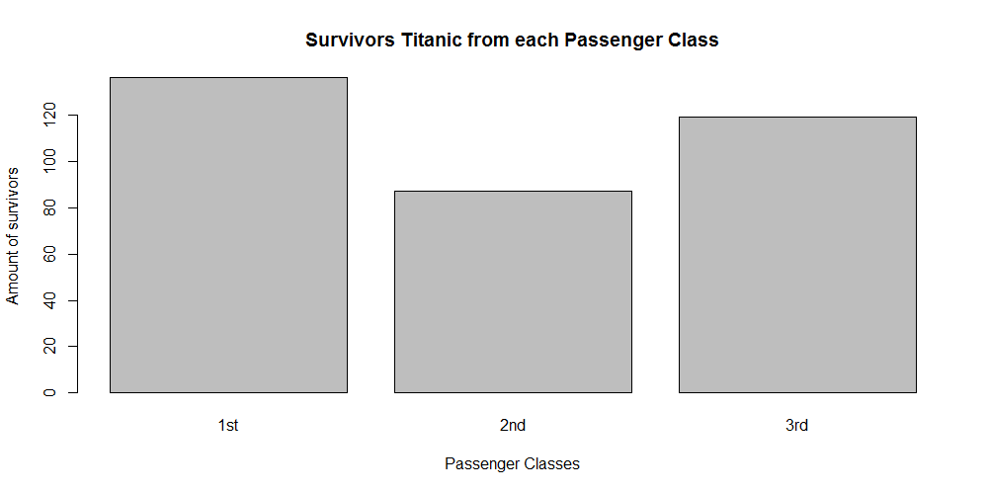

#Find all survivors; 342

survivors <- train[train$Survived==1,]

#Find the Passenger Classes; 1,2,3

levels(factor(survivors$Pclass))

#b1: survivors per passanger class

barplot(

height = c(

sum(survivors$Pclass==1),

sum(survivors$Pclass==2),

sum(survivors$Pclass==3)

),

names.arg=c(

"1st","2nd","3rd"

),

xlab="Passenger Classes",ylab="Amount of survivors",

main="Survivors Titanic from each Passenger Class"

)

Comment:

*The Barplot shows the amount of survivors from the Titanic, from each Passenger class.  
The first class had the most survivors.*

[6p] Visualization 2:

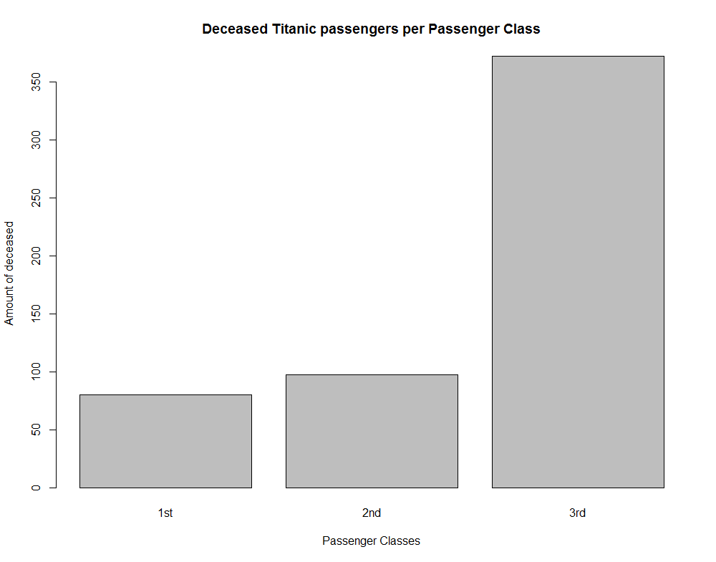

#Find all deceased; 549

deceased <- train[train$Survived==0,]

#b2: deceased per passanger class

barplot(

height = c(

sum(deceased$Pclass==1),

sum(deceased$Pclass==2),

sum(deceased$Pclass==3)

),

names.arg=c(

"1st","2nd","3rd"

),

xlab="Passenger Classes",ylab="Amount of deceased",

main="Deceased Titanic passengers per Passenger Class"

)

Comment:

*The Barplot shows the amount of deceased passengers from the Titanic, per each Passenger class.  
The third class had the highest death toll.*

[6p] Visualization 3:

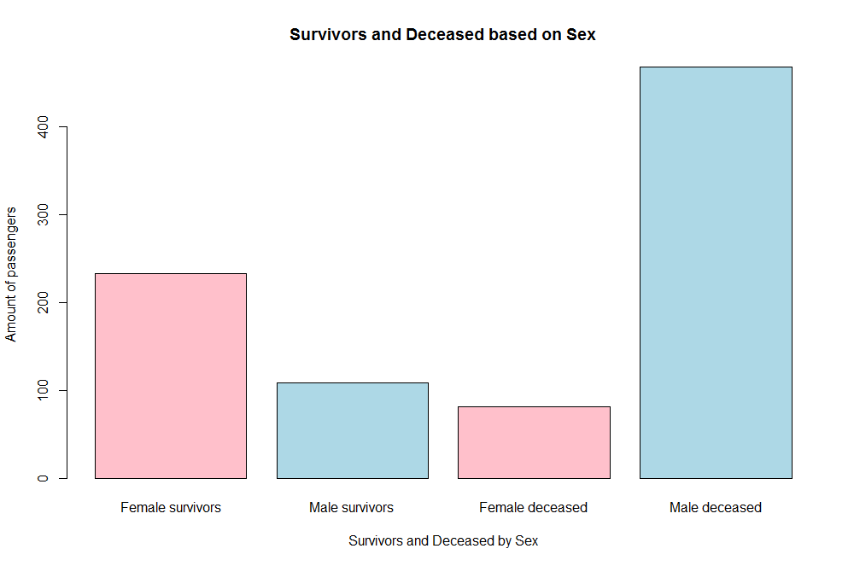

female_survivors <- survivors[survivors$Sex == "female",]

male_survivors <- survivors[survivors$Sex == "male",]

female_deceased <- deceased[deceased$Sex == "female",]

male_deceased <- deceased[deceased$Sex == "male",]

library(plyr)

female_survivors <- count(female_survivors, c("Survived"))$freq

male_survivors <- count(male_survivors, c("Survived"))$freq

female_deceased <- count(female_deceased, c("Survived"))$freq

male_deceased <- count(male_deceased, c("Survived"))$freq

barplot(

c(female_survivors, male_survivors, female_deceased, male_deceased),

names.arg=c("Female survivors", "Male survivors", "Female deceased", "Male deceased"),

main="Survivors and Deceased based on Sex",

xlab="Survivors and Deceased by Sex",

ylab="Amount of passengers",

col=c("pink", "lightblue", "pink", "lightblue")

)

Comment: *[explanation about the visualization]*

*The Barplot shows the amount of survivors and deceased per gender.  
The first two bars show the survivors, the 3th and 4th bar show the deceased passangers.  
Both genders have a corresponding colour.  
You can see that more male passangers deceased then female, and that more female passangers survived then male.*

[6p] Visualization 4:

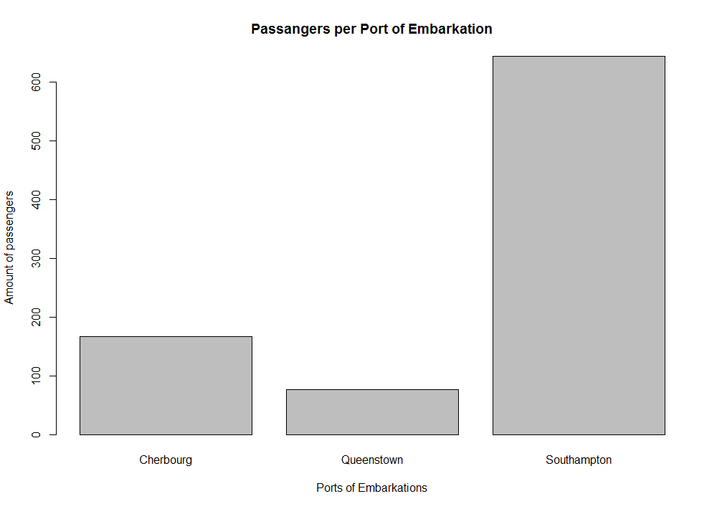

embarkations <- train[train$Embarked != "",]

embarkations <- count(embarkations$Embarked)

barplot(embarkations$freq,

names.arg=c("Cherbourg", "Queenstown", "Southampton"),

main="Passangers per Port of Embarkation",

xlab="Ports of Embarkations",

ylab="Amount of passengers"

)

Comment: *[explanation about the visualization]*

*The visual show the amount of passangers per port of embarkation.  
The most passangers entered the ship from the Southampton port.*

1. [12p] [*Week 4; Chapters 3,4 Dalgaard*] Consider the Age variable. Compute its mean and its standard deviation. Then, put in the same plot:
   * the density function of the Normal distribution, using as parameters the mean and standard deviation of Age;
   * a histogram of the Age variable.

For the histogram, remember that you can specify the starting position of the bars using the option “*breaks*”. To add a histogram to an existing plot, use the option “*add=T*”. Try to make the plot as good-looking as possible.

Then, produce also the Q-Q plot for the Age variable.

[1p] Mean of Age: 29.69912

[1p] Standard deviation of Age: 14.5265

[5p] Plot of Normal distribution and histogram of Age (together in only one plot!):

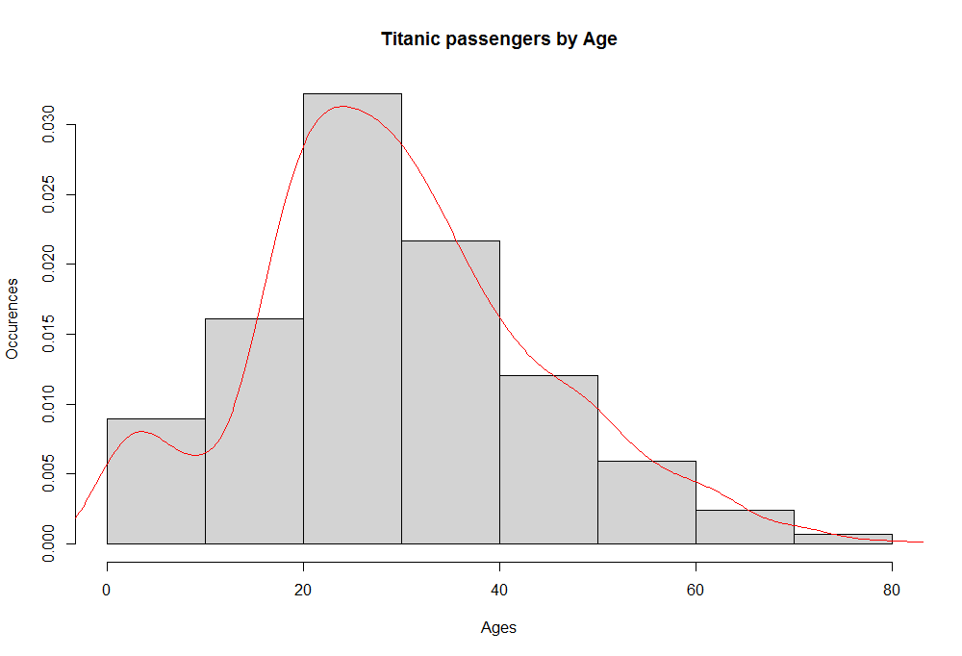  
  
 [2p] Q-Q plot for the Age variable:

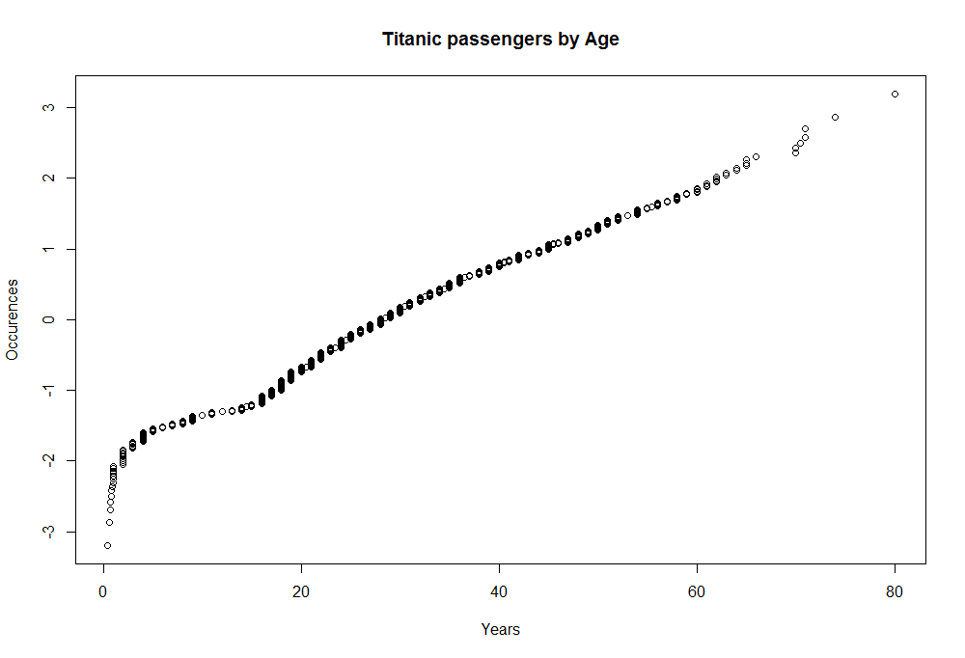

[3p] Looking at the two plots, do you think that the Age variable is normally distributed? Why?

**No**, you can see a peak between the age of 20 and 30 years old. This age group is kind of in the center, **but** it’s not a complete bell shape. There are more passangers older than 40 years old, then people younger than 20 years old.

1. [9p] [*Week 4; Chapter 6 Yakir*] Using the results obtained at point c), suppose that Age is really distributed as a Normal random variable and compute:

[3p] The probability that a passenger is younger than 12

🡪 R code:

**mAge <- mean(train$Age, na.rm=T)**

**sdAge <- sd(train$Age, na.rm=T)**

**pnorm(12,mAge,sdAge) - pnorm(0,mAge,sdAge)**

🡪 Result: 0.09108244

[3p] The probability that a passenger is between 20 and 50 years old

🡪 R code:  
**pnorm(50,mAge,sdAge) - pnorm(20,mAge,sdAge)**

🡪 Result: 0.6667019

[3p] The probability that a passenger is older than 65

🡪 R code:  
**pnorm(max(train$Age, na.rm=T), mAge,sdAge) - pnorm(65,mAge,sdAge)**

🡪 Result: 0.007279876

1. [40p] [*Week 6; Chapter 5 Dalgaard*] Execute statistical tests to answer the following research questions. [Note: in order to execute some of the tests, you could need to create new vectors of values starting from the original dataset variables]

[10p] Research question 1: Was there a different **survival** **rate** between men and women? In other words, did you have more chances of being saved depending on your sex?

*[copy and paste here the R* ***code*** *and* ***output*** *of the test]*

Answer: *[motivate the answer based on values from the R output]*

*_______________________________________________________________________________*

*_______________________________________________________________________________*

*_______________________________________________________________________________*

*_______________________________________________________________________________*

[15p] Research question 2: Was there a different survival rate between the “critical age” people and the other? Let us define the “critical age” as being a child ( $≤8$ years old) or a senior ( $≥ 65$ years old). In other words, did you have more chances of being saved if you were in a “critical age”?

*[copy and paste here the R* ***code*** *and* ***output*** *of the test]*

Answer: *[motivate the answer based on values from the R output]*

*_______________________________________________________________________________*

*_______________________________________________________________________________*

*_______________________________________________________________________________*

*_______________________________________________________________________________*

[15p] Research question 3: Was there a different survival rate between the people of different passenger classes? In other words, did you have more chances of being saved if you were in an upper class? [Careful: there are 3 passenger classes but you cannot make a test on 3 vectors at the same time...]

*[copy and paste here the R* ***code*** *and* ***output*** *of the test(s)]*

Answer: *[motivate the answer based on values from the R output]*

*_______________________________________________________________________________*

*_______________________________________________________________________________*

*_______________________________________________________________________________*

*_______________________________________________________________________________*

1. [15p] [*Week 7; Chapter 6 Dalgaard*] Consider the variables Fare and Age. Plot the fare in function of the age. Fit a linear regression model on these two variables and add the resulting line on the plot. Get the summary of the model and investigate on the existence of a relationship between the two variables.

[5p] Linear regression:

*[copy and paste here the* ***plot*** *with the points and the line obtained from the regression model]*

[2p] Summary of the model:

*[put here the* ***output*** *of the regression model summary]*

[1p] Value of the intercept of the model: _____________

[1p] Value of the slope of the model: _____________

[1p] Equation of the linear regression model: _____________

[5p] From the resulting model summary (and looking at the plot), do you think that there is a relationship between Fare and Age? In other words, did you pay consistently less (or more) for your ticket, depending on your age? [*motivate your answer referring to specific numbers/features of the summary/plot*] *_______________________________________________________________________________*

*_______________________________________________________________________________*

*_______________________________________________________________________________*

*_______________________________________________________________________________*